**Reading an excel file using Python openpyxl module**

**Openpyxl** is a Python library for reading and writing Excel (with extension xlsx/xlsm/xltx/xltm) files. The Openpyxl Module allows [Python programs](https://www.geeksforgeeks.org/python-programming-examples/) to read and modify Excel files. For example, users might have to go through thousands of rows and pick out a few handfuls of information to make small changes based on some criteria. Using Openpyxl module, these tasks can be done very efficiently and easily.

**Installation**

Use this command to install openpyxl module

pip install openpyxl

**Input file**

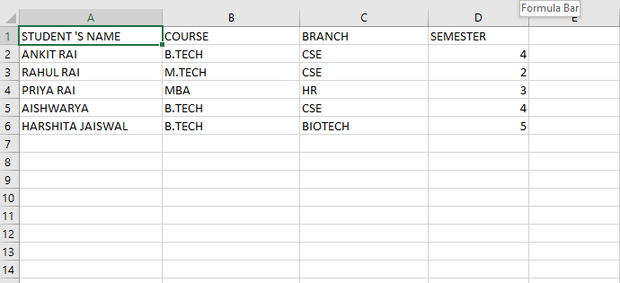

**Table of Content**

* [Program to Print the Particular Cell Value](https://www.geeksforgeeks.org/python-reading-excel-file-using-openpyxl-module/#program-to-print-the-particular-cell-value)
* [Determine Total Number of Rows](https://www.geeksforgeeks.org/python-reading-excel-file-using-openpyxl-module/#determine-total-number-of-rows)
* [Determine Total Number of Columns](https://www.geeksforgeeks.org/python-reading-excel-file-using-openpyxl-module/#determine-total-number-of-columns)
* [Print all Columns Name](https://www.geeksforgeeks.org/python-reading-excel-file-using-openpyxl-module/#print-all-columns-name)
* [Print first Column Value](https://www.geeksforgeeks.org/python-reading-excel-file-using-openpyxl-module/#print-first-column-value)
* [Print a Particular Row Value](https://www.geeksforgeeks.org/python-reading-excel-file-using-openpyxl-module/#print-a-particular-row-value)

**Program to Print the Particular Cell Value**

# import openpyxl module

import openpyxl

# Give the location of the file

path = "C:\\Users\\Admin\\Desktop\\demo.xlsx"

# To open the workbook

# workbook object is created

wb_obj = openpyxl.load_workbook(path)

# Get workbook active sheet object

# from the active attribute

sheet_obj = wb_obj.active

# Cell objects also have a row, column,

# and coordinate attributes that provide

# location information for the cell.

# Note: The first row or

# column integer is 1, not 0.

# Cell object is created by using

# sheet object's cell() method.

cell_obj = sheet_obj.cell(row = 1, column = 1)

# Print value of cell object

# using the value attribute

print(cell_obj.value)

**Output:**

STUDENT 'S NAME

**Determine Total Number of Rows**

# import openpyxl module

import openpyxl

# Give the location of the file

path = "C:\\Users\\Admin\\Desktop\\demo.xlsx"

# to open the workbook

# workbook object is created

wb_obj = openpyxl.load_workbook(path)

sheet_obj = wb_obj.active

# print the total number of rows

print(sheet_obj.max_row)

**Output**

6

**Determine Total Number of Columns**

# importing openpyxl module

import openpyxl

# Give the location of the file

path = "C:\\Users\\Admin\\Desktop\\demo.xlsx"

# workbook object is created

wb_obj = openpyxl.load_workbook(path)

sheet_obj = wb_obj.active

# print total number of column

print(sheet_obj.max_column)

**Output**

4

**Print all Columns Name**

# importing openpyxl module

import openpyxl

# Give the location of the file

path = "C:\\Users\\Admin\\Desktop\\demo.xlsx"

# workbook object is created

wb_obj = openpyxl.load_workbook(path)

sheet_obj = wb_obj.active

max_col = sheet_obj.max_column

# Loop will print all columns name

for i in range(1, max_col + 1):

cell_obj = sheet_obj.cell(row=1, column=i)

print(cell_obj.value)

**Output**

STUDENT 'S NAME

COURSE

BRANCH

SEMESTER

**Print first Column Value**

# importing openpyxl module

import openpyxl

# Give the location of the file

path = "C:\\Users\\Admin\\Desktop\\demo.xlsx"

# workbook object is created

wb_obj = openpyxl.load_workbook(path)

sheet_obj = wb_obj.active

m_row = sheet_obj.max_row

# Loop will print all values

# of first column

for i in range(1, m_row + 1):

cell_obj = sheet_obj.cell(row=i, column=1)

print(cell_obj.value)

**Output:**

STUDENT 'S NAME

ANKIT RAI

RAHUL RAI

PRIYA RAI

AISHWARYA

HARSHITA JAISWAL

**Print a Particular Row Value**

# importing openpyxl module

import openpyxl

# Give the location of the file

path = "C:\\Users\\Admin\\Desktop\\demo.xlsx"

# workbook object is created

wb_obj = openpyxl.load_workbook(path)

sheet_obj = wb_obj.active

max_col = sheet_obj.max_column

# Will print a particular row value

for i in range(1, max_col + 1):

cell_obj = sheet_obj.cell(row=2, column=i)

print(cell_obj.value, end=" ")

**Output:**

ANKIT RAI B.TECH CSE 4

<https://www.geeksforgeeks.org/python-reading-excel-file-using-openpyxl-module/>